

**Assignment II**

1. Write a program to calculate (a+b)2.
2. C++ Program to calculate (a-b)2.
3. Write a program to calculate (a+b)3.
4. C++ Program to calculate (a-b)3
5. Program to calculate a3+b3.
6. Program to calculate a3-b3.
7. Program to calculate a2+b2.
8. Program to calculate a2-b2.
9. Program to calculate (a+b+c)2.
10. Program to calculate (a-b-c)2.
11. Write a program to calculate (a+b)4.
12. Write a program to calculate (a-b)4.
13. C++ Program to calculate the area and perimeter of the parallelogram.

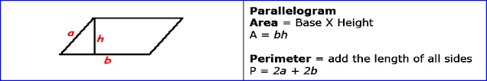

### C++ Program to calculate the area and perimeter of the triangle.

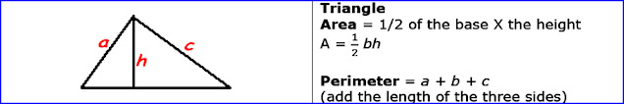

### C++ Program to calculate the area of the Trapezoid.

### Trapezoid.jpg

### C++ Program to calculate the perimeter of the Trapezoid.

### Trapezoid (1).jpg

### C++ Program to calculate the diameter, area and circumference of the circle.

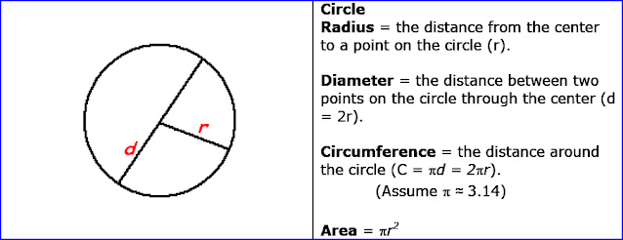

1. [Write a C++ program to enter marks of five subjects and calculate total, average and percentage.](https://www.cprogramcoding.com/2020/07/basic-c-programming-exercises.html)